Questions 3 & 4:

A teacher wants to increase interest in STEM careers in middle school students (research has shown that this is a key time frame to introduce potential career paths). The teacher decides to test different types of STEM presentations to a group of boys and girls. The teacher gives the student a short questionnaire about careers in science before and after the presentations to assess the children’s initial and subsequent views on STEM careers. The teacher presented students with either a professionally made video, another teacher, or an actual practicing STEM professional.

* Run a mixed factorial design (with pre/post as the repeated) measure and interpret the results of the analysis.

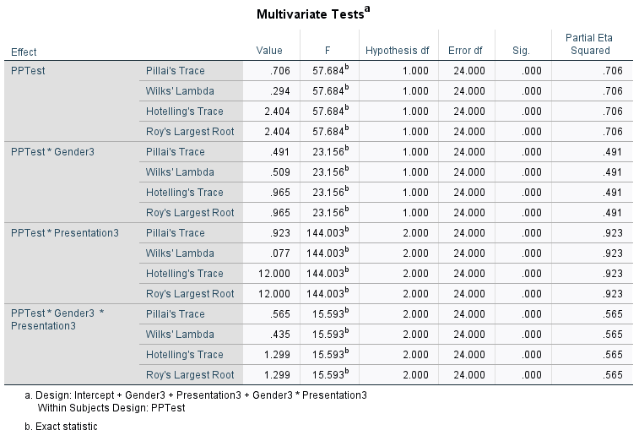

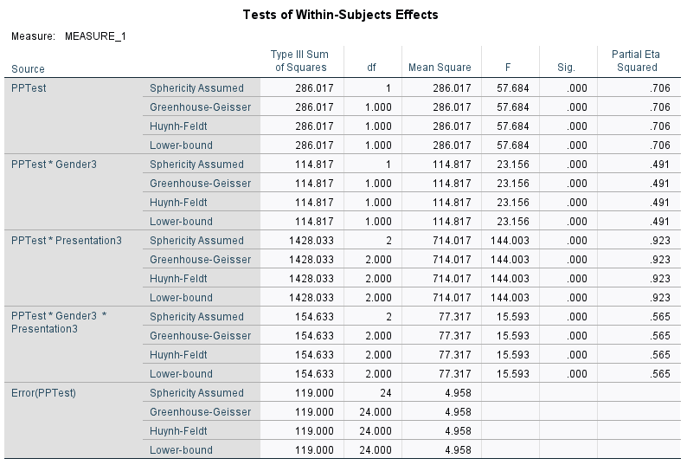

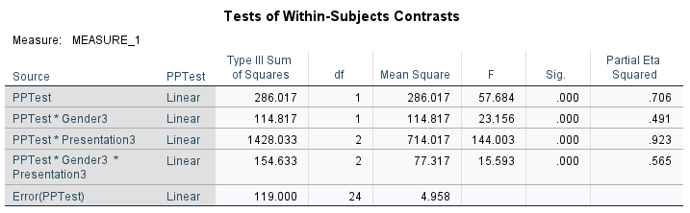

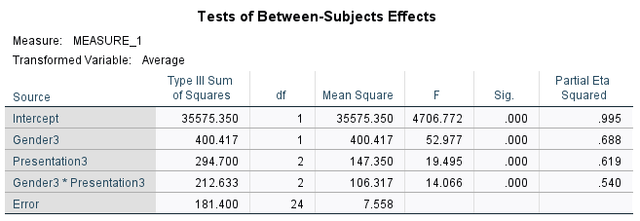

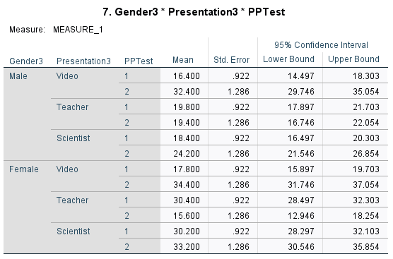

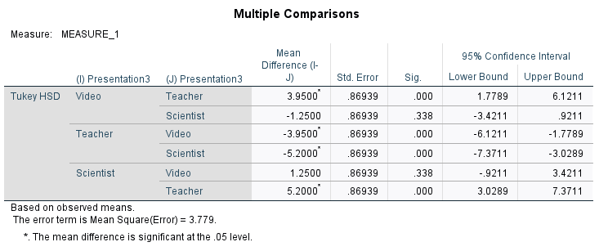

**Part 2: Question 3: Interpretation**

A mixed factorial analysis was conducted to investigate how gender (male or male), test (pre and post), and different presentations method influences middle school students’ interest in STEM. The means and standard deviations for the learning recall are presented in Table 2.2 below. From within subject effects, the result of the analysis indicated a significant main effect for test, *F*(1,24) = 57.684, *p*(0.000) < 0.05, partial ɳ2 = 0.706. likewise, from between subject effects, there was a significant main effect for gender, *F*(1,24) = 52.977, *p*(0.000) < 0.05, partial ɳ2 = 0.688. Also, there was a significant main effect for presentation methods, *F*(2,24) = 19.495, *p*(0.000) < 0.05, partial ɳ2 = 0.619. Interms of interaction, there were significant interaction effects from both within and between subject effects. From within subject effects, there was a significant interaction effect for test and gender, *F*(1,24) = 23.156, *p*(0.000) < 0.05, partial ɳ2 = 0.491. Also, there was a significant interaction effect for test and presentation, *F*(2,24) = 144.003, *p*(0.000) < 0.05, partial ɳ2 = 0.923. At the same time, there was a significant interaction effect for test, gender and presentation, *F*(2,24) = 15.593, *p*(0.000) < 0.05, partial ɳ2 = 0.565.

Table 2.2. Mean and Standard Deviation for Question 3

|  |  |  |  |  |
| --- | --- | --- | --- | --- |
| Test | Gender | Presentation | M | SD |
| PreTest | Male | Video | 16.4000 | 1.94936 |
| Teacher | 19.8000 | 1.30384 |
| Scientist | 18.4000 | 2.07364 |
| Female | Video | 17.8000 | 2.16795 |
| Teacher | 30.4000 | 2.70185 |
| Scientist | 30.2000 | 1.92354 |
| PostTest | Male | Video | 32.4000 | 1.81659 |
| Teacher | 19.4000 | 3.04959 |
| Scientist | 24.2000 | 1.64317 |
| Female | Video | 34.4000 | 2.07364 |
| Teacher | 15.6000 | 4.61519 |
| Scientist | 33.2000 | 2.94958 |

Because the interaction between test, gender and presentation was significant, we chose to ignore the test main effect and instead examined the test simple main effects - that is, the difference among pretest and posttest. Referring to the mean table above (Table 2.2), it is obvious that female that took the posttest questionnaire and watch the video presentation are more like to show more interest in STEM. Also, female that are present in the scientist presentations both during pretest and posttest and also took both pretest and posttest questionnaires are more likely to have more interest in STEM.

* Run these data with the pretest as a covariate (ANCOVA) and interpret the results of the analysis.

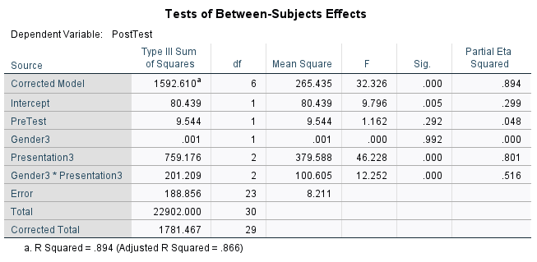

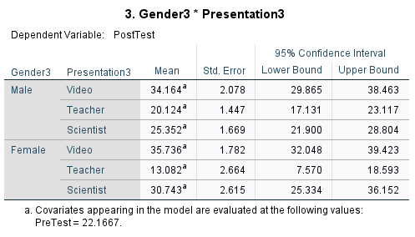

**Part 2: Question 4: Interpretation**

Analysis of covariance (ANCOVA) was conducted. The independent variables, gender, included two levels: male and female and presentation, included three levels: video, teacher, and scientist. The dependent variable was taken to be the posttest and the covariant was the pretest. The output of the analysis indicated that the relationship between the covariate (pretest) and the dependent variable (posttest) was significant as a function of the independent variables (gender*presentation), F(2, 23) = 12.252, p(0.000) <0.05, partial ɳ2 = 0.516. likewise, the relationship between the dependent variable and presentation was significant, F(2, 23) = 46.228, p(0.000) <0.05, partial ɳ2 = 0.801. We could notice that the strength of relationship between the presentation and dependent variable was very strong, as assessed by a partial ɳ2, with the presentation factor accounting for 80% of the variance. However, after accounting for covariant, the relationship between the dependent variable and gender was nonsignificant, F(1, 23) = 0.000, p(0.000) <0.05, partial ɳ2 = 0.00. The means of the posttest adjusted for presentation indicated that, female that watch video and engaged in posttest are more likely to show interest in STEM (M= 35.74), followed by male that watches video (M = 34.16).

* How does the outcome/interpretation of these data change between the two analyses?

The outcome of this analysis makes it possible to find the relationship between the dependent variable and the independent variable while keeping covariant factor constant.

* Which approach do you think is more appropriate (and why)?

ANCOVA approach is appropriate because it help to better understand how a factor impacts a dependent variable (DV) after accounting for some covariate(s).

Questions 5 & 6:

A researcher wants to examine the potential benefits of diet and exercise on two commonly used markers of health, weight and cholesterol levels. Participants were assigned to one of four combinations of diet/exercise (2 x 2) and had their weight (pounds) and cholesterol (LDL) measured.

* Run as a factorial design with a covariate (weight) and interpret the results.

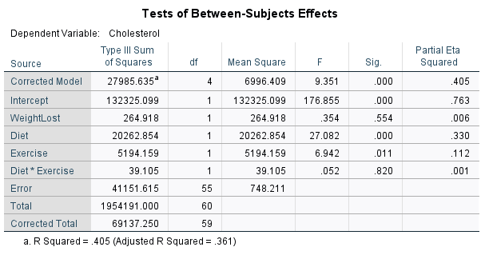

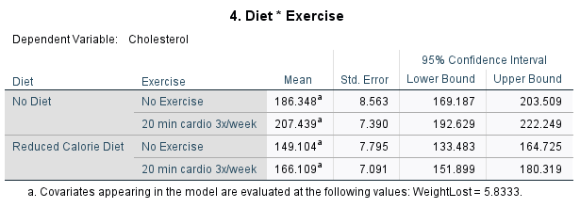

**Part 2: Question 5: Interpretation**

Analysis of covariance (ANCOVA) was conducted. The independent variables, diet, included two levels: no diet and reduced calorie diet, and exercise, included two levels: no exercise and 20 min cardio 3x/week. The dependent variable was taken to be the cholesterol and the covariant was weight. The output of the analysis indicated that the relationship between the covariant (weight) and the dependent variable (cholesterol) was nonsignificant as a function of the independent variables (diet*exercise), F(1, 55) = 0.052, p(0.820) > 0.05, partial ɳ2 = 0.01. However, the relationship between the dependent variable and exercise was significant, *F*(1, 55) = 6.942, p(0.011) <0.05, partial ɳ2 = 0.112. Furthermore, after accounting for covariant, the relationship between the dependent variable and diet was also significant, F(1, 55) = 27.082, p(0.000) <0.05, partial ɳ2 = 0.330. The means of the weight adjusted for the cholesterol indicated that, reduced calorie diet with 20min cardio 3x/week, yields a lesser and more reasonable cholesterol reduction (M = 166.11).